 | Our ref:
 | Your ref:
 | If calling ask for: | School Office
 | Phone:
 | Date:

Dear Parent/Carer of P7 Pupil

National Entitlement & Young Scot Card – School Meals / Free Bus Travel

Within South Lanarkshire Secondary Schools, we use a smart card to pay for school meals. All S1 pupils will have an induction into the process for purchasing school meals using this card on their first day at their new Secondary School in August.

This card is a multi-use card which combines School Meals, Free Bus Travel National Entitlement and Young Scot cards into one. The card allows young people to get easier access to their entitlements, minimises the number of cards they need to carry and encourages responsible use of a card which has some currency value.

Please find enclosed an application form which has been pre-printed using existing school data for your child. Please check the details are accurate, indicate whether you wish your child to have Free Bus Travel or if they already have this, sign and return the form to your primary school by Monday, 25 April 2022.

If you child requires a NEC card their photograph will then be taken and the form and photograph processed so that your child’s card will be available for them starting secondary school in August.

Thank you in anticipation of your support in completing and returning the paperwork.

Yours faithfully

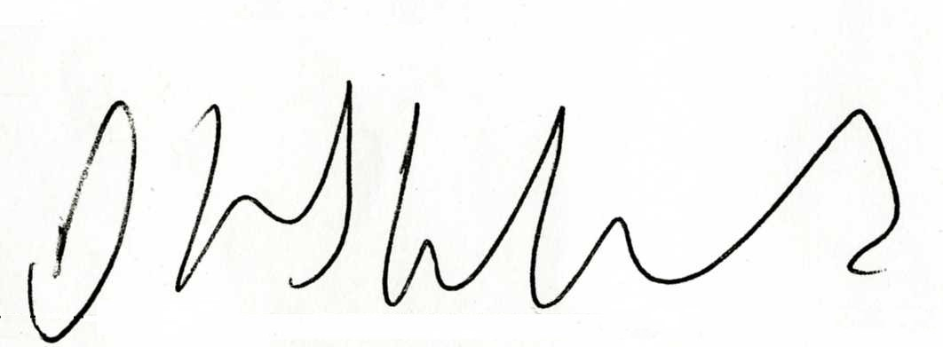

David Hinshelwood
Support Services Manager

