Standards and Quality Report 2018-19

Park View Primary

- School & National Context

Context of the School

Park View Primary School is located in the Halfway area of South Lanarkshire. The current school role is 192 with the pupils spread across seven classes. The local area is a mix of social and privately owned housing. We have a mixture of composite and non-composite classes. For this session, we have had two P1/2 classes along with P3, P3/4, P5, P5/6 and P6/7. Both P1/2 classes and the P3/4 class have two teachers working in them.

Park View opened as a brand new school in August 2013 following a catchment review and has continued to grow ever since.

At Park View, we have four core values. These are Politeness, Ambition, Responsibility and Kindness. We aim to promote these at all times. Our school motto is ‘We Create. We Challenge. We Care.’ This is the vision we have for our school.

We have an extremely committed and hardworking staff team comprised of a Head Teacher, a Principal Teacher and 10.6 permanent members of teaching staff. During this session, we used some of our PEF allocation to buy in an area cover teacher to help raise attainment in writing. We also have an NQT and a Specialist Support Teacher who visits 1 day per week (AM only). There are five Pupil Support Assistants (one only working 2 days per week) and a Team Leader.

Park View Primary is part of the Stonelaw High Learning Community. We have good links with the other primary schools and the high school. These links continue to be strengthened to ensure smooth transition for pupils moving from P7 to S1.

We have an active and supportive Parent Partnership. They support the school in a number of ways including fundraising. They also played a significant role in funding and organising our outdoor classroom and Trim Trail.

Although our roll has fluctuated throughout the year, on average 35% of our pupils live in SIMD 1 and SIMD 2 and 18% are entitled to a free school meal. 40% of our school roll are in the PEF target group.

The National Context for Education
The National Improvement Framework (NIF) for Scottish Education sets out the Scottish Government’s vision to continually improve Scottish Education and to close the attainment gap, delivering both excellence and equity. Our school, working in partnership with South Lanarkshire Council is fully committed to delivering these ambitious aims.
The key priorities of the National Improvement Framework are:
- Improvement in attainment, particularly in literacy and numeracy
- Closing the attainment gap between the most and least disadvantaged children
- Improvement in children and young people’s health and wellbeing
- Improvement in employability skills and sustained, positive school leaver destinations for all young people

Key drivers of improvement have also been identified, these are:
- School leadership.
- Teacher professionalism.
- Parental engagement.
- Assessment of children’s progress.
- School improvement.
- Performance information.

South Lanarkshire Council’s overall vision is to “improve the quality of life of everyone in South Lanarkshire Council.”
Education Resources’ key purpose is to:
“Raise achievement and attainment, inspire learners, transform learning and work in partnership to strengthen our communities”
The priorities relating to this are:
- Deliver high-quality early learning and childcare to give our children the best educational start
- Raise standards in literacy, numeracy and close the poverty-related attainment gap.
- Improve health and wellbeing to enable children and families to flourish.
- Support children and young people to develop their skills for learning, life and work.
- Ensure inclusion and equality are at the heart of what we do.

Our school is committed to taking these priorities forward and developing each driver through our annual School Improvement Plan (SIP.)

Assessment of children’s progress throughout the Broad General Education (to end of S3)
As one of the drivers, our school, alongside all schools in Scotland, has been required to report on Curriculum for Excellence levels for literacy and numeracy achieved by all children at the end of stages P1, P4, P7 and S3. This data is submitted to South Lanarkshire Council in June each year and collected subsequently by the Scottish Government. This data is based on teacher judgement, informed by a wide range of assessment evidence including standardised testing where appropriate. As from session 2016/17 all schools in Scotland will be required to participate in the new Scotland National Standardised Assessment (SNSA) project. This will further help inform teacher judgement of levels.
The following table shows benchmarks for children achieving Curriculum for Excellence Levels.
Level | Stage covering 3 years approx.
Early | The pre-school years and P1, or later for some.
First | To the end of P4, but earlier or later for some.
Second | To the end of P7, but earlier or later for some.
Third and Fourth | S1 to S3, but earlier for some.  The fourth level broadly equates to Scottish Credit and Qualifications Framework level 4.  The fourth level experiences and outcomes are intended to provide possibilities for choice and young people’s programmes will not include all of the fourth level outcomes.
Senior phase | S4 to S6, and college or other means of study.

Some children and young people will start learning at these levels earlier and others later, depending upon individual needs and abilities. Many children not attaining National Levels will have an Additional Support Plan (ASP) and may be making good progress but against different milestones e.g. individual targets. Learning progress is not about how fast children move through the levels but about ‘how much’ and ‘how well’ children learn, having depth and breadth of experiences at each level.
Assessment of these levels is based on a wide variety of evidence and ways of measuring progress such as assessment of projects, general class work, observations and peer assessment. Where possible, children and young people are encouraged to be directly involved in the assessment process.
Schools and teachers work with others to set shared standards for assessing progress. These standards are based on National “benchmarks” for each area of the curriculum. This process is called moderation and it ensures that schools have similar expectations.
What follows is our school’s data about achievement of these levels for session 15/16 through to session 18/19 which represents a three year trend.

- Review of SIP Progress Session
2017-18

Priority 1: Develop and improve learning & teaching in relation to Writing and Spelling

National Improvement Framework Key Priorities  - Improvement in attainment, particularly in literacy and numeracy;  - Closing the attainment gap between the most and least disadvantaged children;  - Improvement in children and young people’s health and wellbeing; and  - Improvement in employability skills and sustained positive school leaver destinations for all young people. | National Improvement Framework Key Drivers  - School leadership  - Teacher professionalism  - Parental engagement  - Assessment of children’s progress  - School improvement  - Performance information
HGIOS 4 QI:
- 2.2 Curriculum
- 2.3 Learning, teaching and assessment
- 2.7 Partnership
- 3.2 Raising attainment and achievement/Securing children’s progress

Progress and Impact:

All of the aims for this priority were fully met this session as listed below:

- Staff in the Writing Working Party created a new format for assessing writing based on the Scottish Criterion Scale and the CfE Benchmark statements to support teacher judgement in assessing Writing levels.
- A staff evaluation of the new Writing Criteria evidenced that all teachers either strongly agreed or agreed that this new format supported their professional judgement in writing.
- Homework tasks have been designed to share information with parents about expected CfE Writing levels.
- The children at the top end of the school have produced good results in spelling. 8 out of 11 P7 pupils (73%) have achieved the appropriate spelling level. Of the 26 children in P6, 14 of them (54%) have achieved a spelling level beyond the one expected.

Next Steps:
- Continue with our ‘Let’s Write’ intervention using a teacher funded from our PEF allocation.
- Implement the ‘Talk4Writing’ approach with support from SLC.
- Refocus on the spelling/phonics program used in infant classes.

Priority 2: Develop and Improve learning and teaching in relation to the processes of addition and subtraction.

National Improvement Framework Key Priorities  - Improvement in attainment, particularly in literacy and numeracy;  - Closing the attainment gap between the most and least disadvantaged children;  - Improvement in children and young people’s health and wellbeing; and  - Improvement in employability skills and sustained positive school leaver destinations for all young people. | National Improvement Framework Key Drivers  - School leadership  - Teacher professionalism  - Parental engagement  - Assessment of children’s progress  - School improvement  - Performance information
HGIOS 4 QI:
- 2.2 Curriculum
- 2.3 Learning, teaching and assessment
- 2.7 Partnership
- 3.2 Raising attainment and achievement/Securing children’s progress

Progress and Impact:
- We allocated 9x50minute periods to Numeracy and Mathematics. This was discussed and agreed on Inset day 1.
- New homework sheets were produced to provide more information for parents/carers when supporting pupils with numeracy tasks.
- All staff attended a CLPL session on ‘Number Talks’.
- Staff implemented the strategies of ‘Counting On’ and ‘Counting Back’ with all classes.
- Staff have reported an increase in pupil confidence and enjoyment since starting Numeracy lessons with a Number Talks session.
- The Numeracy Development Group created a document (in Power Point format) containing common methodology and terminology to be used when teaching addition and subtraction.
- Interim and Final Benchmark statements have been added to all of our Numeracy planners. This has made it much clearer to staff where children are within a level and has supported them in making professional judgements.
- We have seen an increase in our attainment in Numeracy and Mathematics from

Next Steps:
- Implement more of the strategies from ‘Number Talks’ during next session.
- Launch new Numeracy planners containing interim and final benchmark statements to all staff during August Inset.
- Further develop the common methodology and terminology document to include multiplication and division.
- Organise some ‘Find out More’ sessions for parents/carers, where approaches used to teach calculations will be shared. They will then have opportunities to join in some Numeracy lessons in class.

Priority 3: Provide additional personalised support for pupils in relation to conflict resolution and positive behaviour.

National Improvement Framework Key Priorities  - Improvement in attainment, particularly in literacy and numeracy;  - Closing the attainment gap between the most and least disadvantaged children;  - Improvement in children and young people’s health and wellbeing; and  - Improvement in employability skills and sustained positive school leaver destinations for all young people. | National Improvement Framework Key Drivers  - School leadership  - Teacher professionalism  - Parental engagement  - Assessment of children’s progress  - School improvement  - Performance information
HGIOS 4 QI:
- 2.4 Personalised Support
- 3.1 Ensuring wellbeing, equality and inclusion
- 3.3 Increasing creativity and employability/Developing creativity and skills for life and learning

Progress and Impact:
- PPB and Restorative Approaches training was delivered by the Head Teacher on Inset Day 2 in August 2018.
- A variety of GO groups (Getting On) were set up and run by a class teacher (R. Stobo). The initial group targeted four older girls.
- Class Teacher (S. Sheikh) completed Custtad training and set up a Custtad room within the school.
- S. Sheikh has liaised with staff to identify some pupils to work with in order to support them with low to moderate behavior issues and try to support them to adjust their behavior. Since completion of training, three children have been referred and taken part in sessions.
- Class teachers have reported that two out of the three children referred have shown much more settled behaviour in class. One child who is still experiencing difficulty with his day-to-day emotions has been recommended for a different Nurture approach within the school for next session.

Next Steps:
- Continue to provide a wide range of group and individual support sessions to benefit identified pupils.
- Relaunch the GUAB (Give Us a Break) group, as teacher will return from long-term absence.

Priority 4: Improve pupil attendance and punctuality

National Improvement Framework Key Priorities  - Improvement in attainment, particularly in literacy and numeracy;  - Closing the attainment gap between the most and least disadvantaged children;  - Improvement in children and young people’s health and wellbeing; and  - Improvement in employability skills and sustained positive school leaver destinations for all young people. | National Improvement Framework Key Drivers  - School leadership  - Teacher professionalism  - Parental engagement  - Assessment of children’s progress  - School improvement  - Performance information
HGIOS 4 QI:
- 2.4 Personalised support
- 2.7 Partnership
- 3.2 Raising attainment and achievement/Securing children’s progress
- 3.3 Increasing creativity and employability/Developing creativity and skills for life and learning

Progress and Impact:
- We tracked attendance and punctuality using data from Seemis. The data was recorded in a Spread Sheet for each month.
- We rewarded classes for having the best attendance and/or punctuality each month. The rewards were discussed and agreed with the pupil council.
- An attendance and punctuality update became an item on the agenda at every staff meeting.
- We sent out a termly newsletter with a summary of attendance and punctuality.
- Parents were informed either by letter, telephone call or meeting if we had concerns about attendance and/or punctuality

Next Steps:
- A display for class punctuality was created but we now need to create a similar one for attendance.
- We looked at how attendance and punctuality were affecting the attainment of some pupils. This was discussed with parents. We need to now try to use our tracking database to link attendance/punctuality to attainment for all pupils.

- Interventions and progress towards closing the poverty-related gap

Interventions and progress towards closing the poverty-related attainment gap 2018-19

Intervention 1: Raise attainment in Reading
- Increase range of reading resources available.
- Professional learning on approaches and resources used to support struggling readers.
- Increase the number of children using the Catch Up programme.
- Prioritise Literacy support in allocation of support assistants and additional staff.

Evaluative Comment
- We now have six members of staff leading ‘Catch up Literacy’ sessions across the school. A seventh member of staff is currently undergoing training.
- There are now 24 children attending ‘Catch Up’.
- Almost all children are making progress with Catch Up. 19 out of the 24 children (79%) have moved up at least one level and some have moved up several levels.
- For the 24 children taking part in this intervention, there has been an increase in reading age and reading comprehension of 16.5 months and the standardised score for the children has gone up on average by approximately 8.
- Our overall Reading attainment gap has reduced by a further 9% and is now 14%.
- This means we have achieved the target of 15%.

Intervention 2: Raise attainment in Writing
- Facilitate small group sessions on the consolidation of basic skills within each CfE level.
- Provide opportunities for staff to engage in additional professional learning activities linked to teaching and learning in this curricular area.

Evaluative Comment
- Our overall attainment in Writing has increased from the start of the session 2018-19 from 64% to 76%
- The increase in overall attainment has resulted from staff training and implementation of new Writing Criterion for assessing Writing.
- The attainment gap has decreased by 11% from 26% to 15%.
- All staff have attended the Talk4Writing training organised by SLC.
- The new criterion for assessing writing has been used by staff in Term 3 and was used again in Term 4. Staff also used the new scale to carry out a moderation task in writing. Initial staff survey from changes carried out was very positive.
- Staff have reported that they feel more confident when making their professional judgements using new scale. 100% of staff agreed strongly or very strongly with this statement.

Intervention 3: Raise attainment in Numeracy
- Increased range of resources to be used to support the teaching of Numeracy.
- Staff to engage in professional learning linked to the teaching of Numeracy.

Evaluative Comment
- The current overall attainment in Maths and Numeracy is 81%
- Our current attainment gap in Maths and Numeracy is 3%.
- This is down 15% from last session (17-18).
- For the new session, we will prioritise support for PEF target group (particularly in P6 as gap is at widest) with an aim to maintain the gap below 5%.
- All staff took part in professional learning in using ‘Number Talks’ to improve the mental maths ability of the pupils.
- After further discussion during Inset Day 4, staff started to implement some of the strategies from ‘Number Talks’.
- The Numeracy group have created a common language and methodology document for teaching addition and subtraction. This was part of the action plan in our SIP.

Interventions and progress towards closing the poverty-related attainment gap 2018-19

Intervention 4: Support Health & Wellbeing
- Support staff in identifying and addressing key issues related to emotional wellbeing and facilitate opportunities for the pupils to engage in activities linked to promoting wellbeing – with a particular emphasis on including children who are in the PEF target group.
- Facilitate staff training on aspects of Health and Wellbeing – particularly those related to emotional wellbeing.
Evaluative Comment
- Two Wee Worry Workshop groups continue to run within the school.
- The ‘Getting On Group’ continues to run and staff have agreed this intervention led to an improvement in individual pupils’ health and wellbeing.
- It has become apparent that these pupils have improved self-esteem and confidence, and this has improved relationships with their peers.
- These interventions will continue into the next session and will be evaluated specifically for the PEF target group of children.

Intervention 5: Assessment, Data Analysis and Tracking
- Support staff in recording, tracking and analysing assessment data in order to help plan appropriate next steps and interventions for all children, whilst highlighting the achievement and attainment of children within the PEF group.
- Facilitate a Tapestry group within the school to develop staff skill, knowledge and confidence when using a range of formative assessment strategies, which help to progress learning.
Evaluative Comment
Staff have become more competent and skilled in using the database to identify children who require support. This helps to streamline the process of accessing the correct interventions for children. This has improved efficiency within the school to target specific support. The database has given management effective, robust data to reflect on progress. Going into the new session the database will also include tracking and monitoring of the impact of interventions to determine if children should continue on the intervention, progress into main class work or if they need further assessment for a different intervention. The database enables management to accurately analyse the attainment gap for PEF and evaluate the impact of interventions. This provides data rich information to strategically prepare the new school improvement plan and evaluate the current school improvement plan. Tapestry sessions ran for all staff and these will continue in the next session.

Intervention 6: Learning Through Play
- Increase the range of resources available to support pupils in this area and facilitate professional learning related to learning through play.
- Appoint a ‘Learning Through Play’ Coordinator to support staff and manage resources.

Evaluative Comment
- The Play Area continues to be timetabled for Primary 1 -3 pupils.
- Experience and Outcomes are progressively planned for by a class teacher who has taken on responsibility for this area and the theme is regularly changed to engage, motivate and meet the needs of all learners.
- Class teachers continue to make good use of the Play Area and report that pupils’ learning is enhanced as a result of using the Play Area.
- For the next session, we plan to specifically evaluate the impact of our Play Area on the attainment of our PEF target group of children. We also plane to have a more focused ‘Learning Through Play’ approach in our infant classes. This will form part of the school improvement plan.

- School Attainment Data
  - Attainment data - Attainment of Literacy Curriculum for Excellence levels 2015/16, 2016/17, 2017/18 and 2018/19 (teacher judgement).
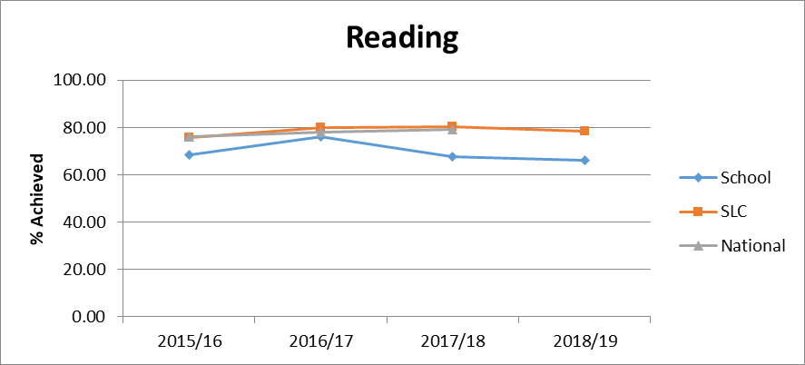

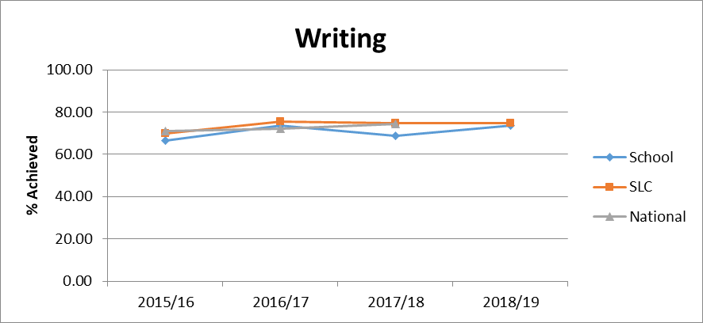

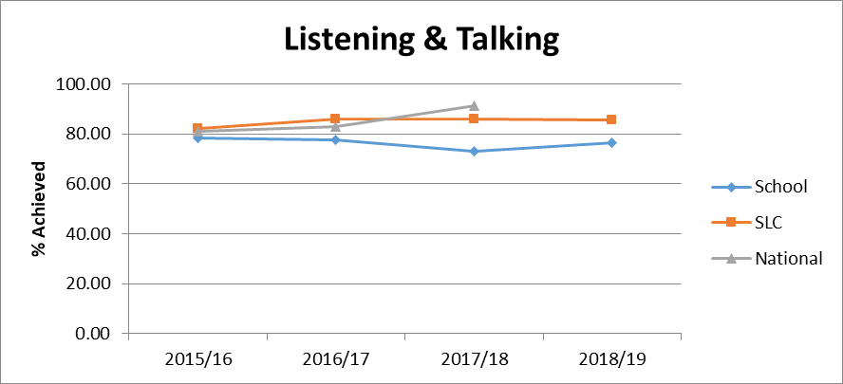

  - Attainment data - Attainment of Numeracy Curriculum for Excellence levels 2015/16, 2016/17, 2017/18 and 2018/19 (teacher judgement).

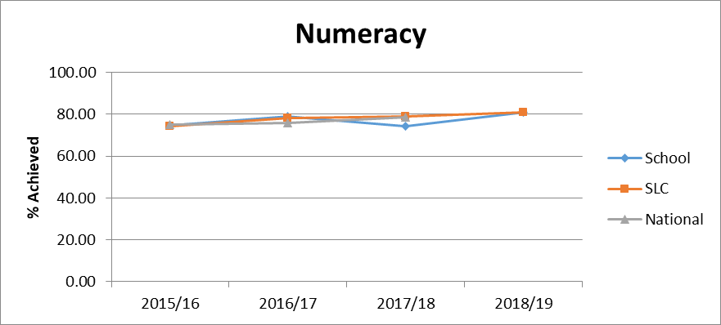

1.3 Poverty-related attainment gap data

The graphs show our whole school poverty-related attainment gap over time. This information is a collation of the percentage of children who are achieving expected CfE levels at stages P1, P4 and P7 according to teacher professional judgement. We have made the biggest progress towards closing the gap within Numeracy. Across the whole school for this year, our analysis shows that we have managed to close the gap to 3% in Numeracy. This is a 15% decrease from session 2017-18.
In 2017-18, Reading showed the biggest gap (25.4%). During this session, we put in place ‘Catch up Literacy’ as an intervention to try to close this gap. Children from P2 to P7 were included but P4 were given the most support, as this was the stage with the lowest attainment in reading. Across the whole school, our analysis shows that the gap in reading has closed by 9% and is now down to 14%.
Listening and Talking showed a gap of 18.4% for session 2017-18. We made Listening and Talking one of the areas of the curriculum taught by a CCC teacher to try to have a more consistent approach. Across the school, the gap for Listening and Talking was 14% for session 2018-19. This meant the gap had closed by 11% from the previous session.
Writing showed a gap of 16.8% for P1, P4 and P7 but a gap of 26% across the whole school for session 2017-18. We used some of our PEF allocation to buy in a teacher to run an intervention in writing called ‘Let’s Write’. Across the whole school, the gap in writing has closed by 11% to 15% during this session. As this is still our highest gap, we plan to use some of this session’s PEF allocation to keep this intervention running.

- Overall Progress

Achieving Excellence: Overall Progress towards National Improvement Framework Priorities
Session 2018-19
Use all available evidence (including data)

Literacy:
Progress | satisfactory | good | very good | excellent
 |  | *

Strengths
- Most of the children (76%) from P1-P7 achieved the expected Cfe Level for Writing in session 2018-19. This was an increase of 14%.
- The gap in writing closed by 11%, down to 15%.
- All teachers participated in professional learning by attending the ‘Talk 4 Writing’ courses run by SLC.
- The P1 Reading baseline score increased by 46% on average between August and March.
- Despite the reading attainment level, with regards to Cfe levels remaining the same, significant progress has been made in raising attainment in Reading through the ‘Catch up Literacy’ intervention. 24 pupils have been working on this intervention. There has been an increase in reading age and reading comprehension of 16.5 months and the standardised score has gone up by approximately 8.
- The gap in Reading closed by 9%, down to 14%.
- Most of the children (84%) from P1-7 achieved the expected Cfe Level in Talking & Listening, with our gap closing from 25% to 14%.
- The children at the top end of the school have produced good results in spelling. 8 out of 11 P7 pupils (73%) have achieved the appropriate spelling level. Of the 26 children in P6, 14 of them (54%) have achieved a spelling level beyond the one expected.

Next steps
- Continue with the use of ‘Catch Up Literacy’.
- Continue with our ‘Let’s Write’ intervention using a teacher funded from our PEF allocation.
- Implement the ‘Talk4Writing’ approach with support from SLC.
- Refocus on the spelling/phonics program used in infant classes.
- Raise attainment in Reading across the school from 66% to 75%.

Numeracy:
Progress | satisfactory | good | very good | excellent
 |  | *

Strengths
- We developed a consistent methodology for teaching addition and subtraction.
- We developed a common language and terminology to be used when teaching addition and subtraction.
- Staff increased their understanding of benchmark statements. Interim and Final benchmark statements were added to all Numeracy planners.
- Most pupils (81%) in P1-P7 achieved the expected Cfe Level during 2018-19. This was an increase of 9%.
- Our gap in Numeracy decreased by 15% to just 3%.

Next steps
- Develop a consistent methodology and common language for the teaching of multiplication and division.
- All staff begin to use the updated Numeracy planners containing interim and final benchmark statements.
- Implement an increased range of strategies from ‘Number Talks’ across all classes.
- Target specific year groups with lowest attainment data (current P4) with interventions such as ‘Maths Recovery’.

Health and Wellbeing
Progress | satisfactory | good | very good | excellent
 |  |  | *

Strengths
- We increased the number of groups run by staff to target interventions with a focus on HWB.
- A class teacher completed Custtad training. A room has now been set up and children have begun to attend sessions.
- We continue to have visitors to the school from the council and further afield to observe some of our HWB interventions such as ‘Wee Worries’.
- Almost all (91%) of children in the school demonstrated very good behavior. Of the 9% of children who received a behaviour card, 70% of them only received one card.
- Almost all (94%) of children in the school were evaluated as being engaged and fully participative in their learning.
- Most children (85%) attended at least one sport’s club after or during school hours. This is an increase of 4% over last session.

Next steps
- Re-introduce our ‘Give Us A Break’ intervention now that a member of staff has returned from long term absence.
- Increase the number of opportunities for children to attend Custtad sessions as required.
- Continue to provide a range of HWB interventions.
- Aim to further increase the number of children participating in sports clubs.

Employability Skills/Positive Destinations
Progress | satisfactory | good | very good | excellent
 |  |  | *

Strengths
- We used the planners and skills progression grids that had been developed last session, across the school.
- During ‘Enterprise Week,’ we had a variety of visitors to speak to the children about their chosen careers. Children also had to dress up to show the job they might do in the future.
- Pupils in P5 took part in a ‘Dragon’s Den’ event where they created their own companies. This was judged in partnership with outside businesses.
- Children were given opportunities to visit different businesses, e.g. Sky and Apple.
- We tracked attendance and punctuality using data from Seemis. The data was recorded in a Spread Sheet for each month.
- Our attendance rate increased from 94% to 94.3% during this session.
- There are currently 19 children (10%) who have an attendance rate of 100%.
- There are a small number of pupils (between 3 and 5%) who have very poor attendance and this is pulling our school average down.
- We rewarded classes for having the best attendance and/or punctuality each month. The rewards were discussed and agreed with the pupil council.
- An attendance and punctuality update became an item on the agenda at every staff meeting.
- We sent out a termly newsletter with a summary of attendance and punctuality.
- Parents were informed by either letter, telephone call or meeting if we had concerns about attendance and/or punctuality.

Next steps
- We looked at how attendance and punctuality were affecting the attainment of some pupils. This was discussed with parents. We need to now try to use our tracking database to link attendance/punctuality to attainment for all pupils.

- Achievements and Highlights

Overall quality of our learners’ achievements
Highlights of session 2018-19
In November, we had a day of dance. ‘Park View Does Strictly’. This started in May with teachers taking part in training during the May Inset Day. All classes learned a dance, which they rehearsed before performing to a packed audience of family and friends.

Staff and pupils took part in ‘Tartan Day’. All classes performed a Scottish poem or song to the rest of the school.
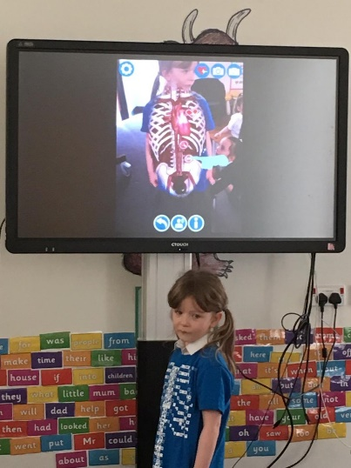
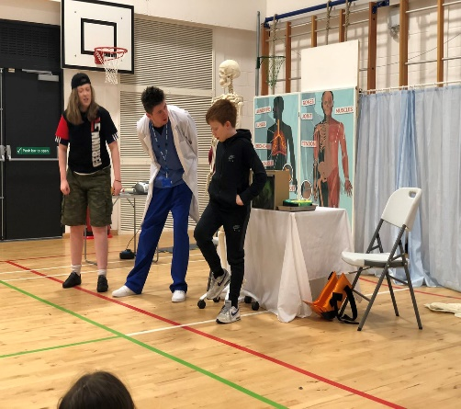
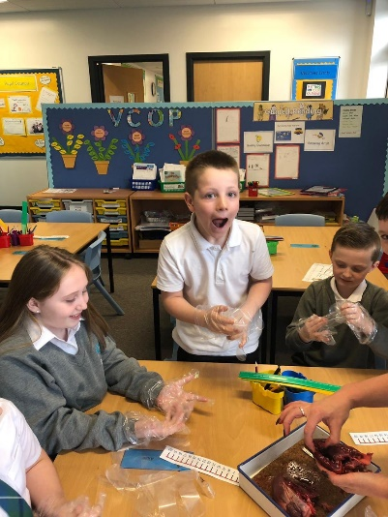
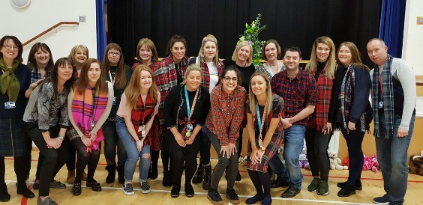
The theme for this year’s STEM week was ‘The Human Body’. Park View staff led activities and we had visits from Generation Science and Science teachers from Stonelaw High. Our senior pupils also visited a local leisure centre to find out more about keeping the body healthy.

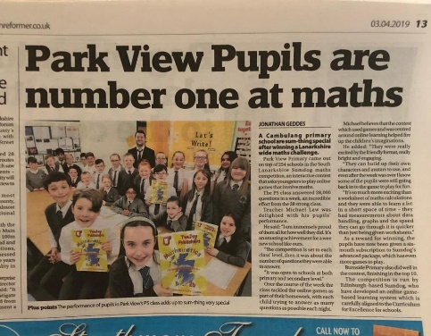
The children have been using ICT more frequently to develop Numeracy skills. Our P5 class came first in the SLC Sumdog competition in March by answering more than 28,000 questions!

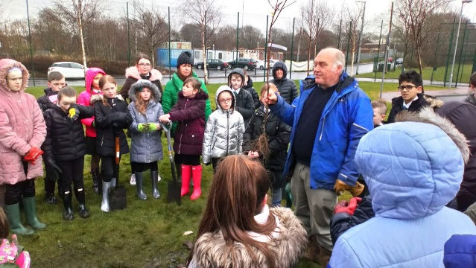
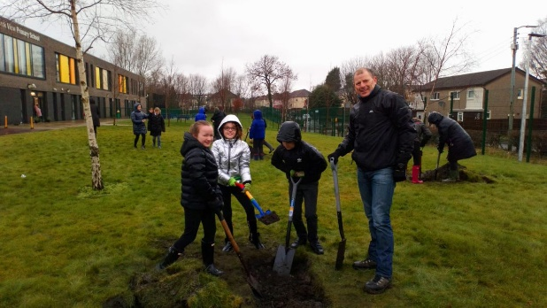

Mrs Sidebotham, one of our PSAs worked with ‘Healthy n Happy’, pupils and parents to plant our own fruit orchard. We now have some apple buds growing on the trees.

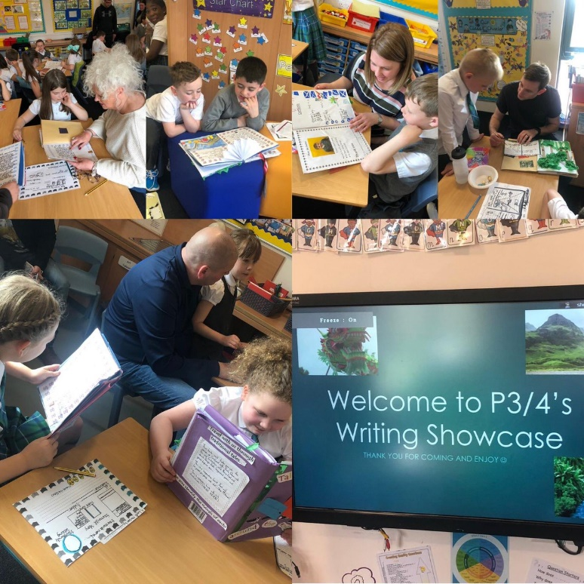
Children in P3/4 took part in an Attainment Families project with James Aiton Primary and Spittal Primary. They went to see a performance by ‘Macastory’, which involved finding out more about stories from around the world. The children then created their own books with stories from around the world. They were joined by parents during the project and then again at the end to see the completed work.

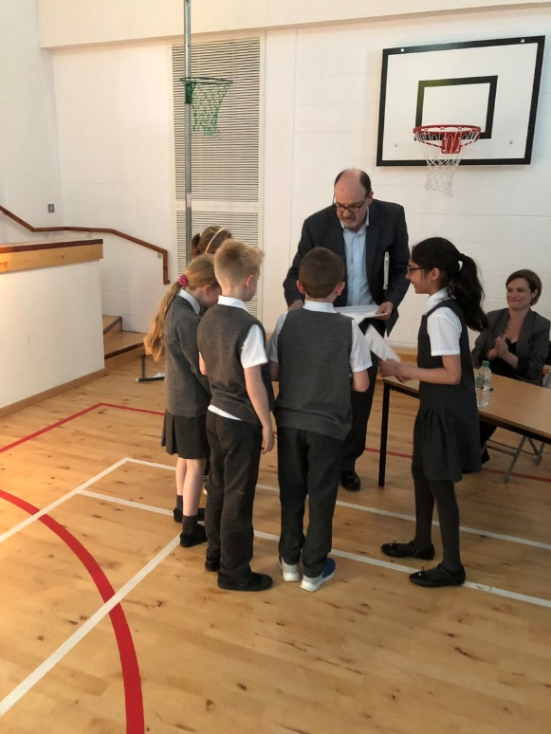

Children in Primary 5 took part in a Dragon’s Den activity. They created their own business and then had to showcase their ideas to some members of the business community. The winning team were taken out for a business lunch by their teacher.

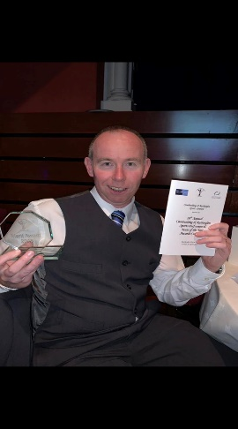

For the third year in a row, Park View won an award at the Rutherglen/Cambuslang sporting awards. We also received the Sport Scotland Silver award for school sport.

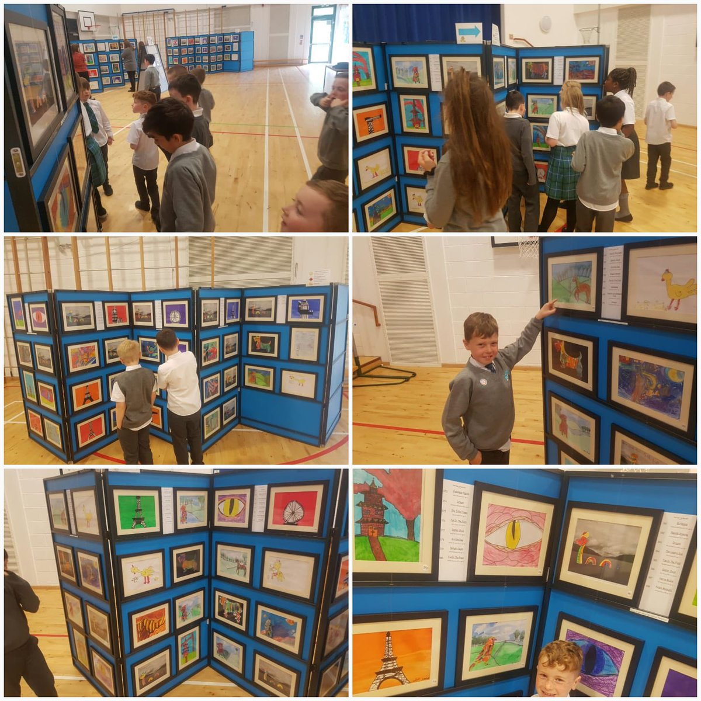

We took part in our first art exhibition in 2019. Children from P1-P7 created a piece of artwork, which was taken away and framed. A gallery was then created. Parents were able to buy finished pieces of work. We sold over 100 pieces of art!

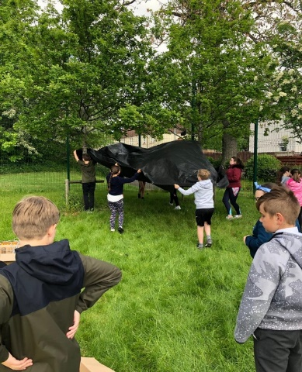
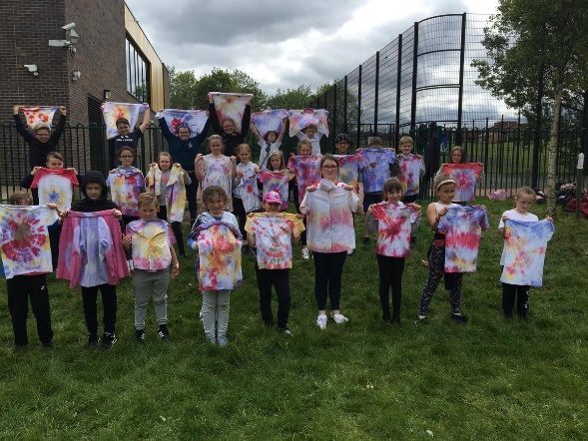
Children from Primary 5, 6 and 7 had a full day of outdoor learning. Amongst other things, they built dens and did some tie-dying of t-shirts.

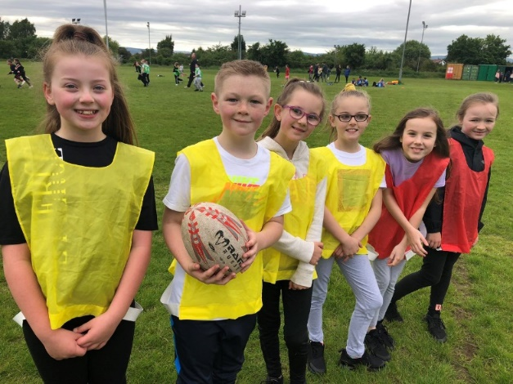
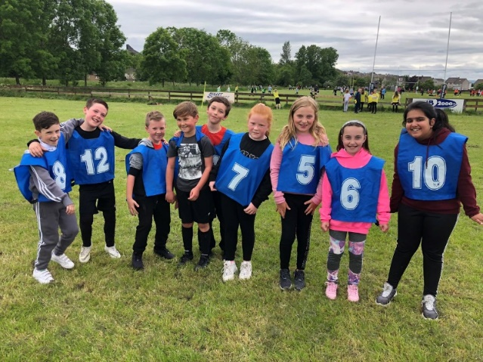

We took part in a rugby festival organised by Cambuslang Rugby Club. The children had a great time and finished in third place.

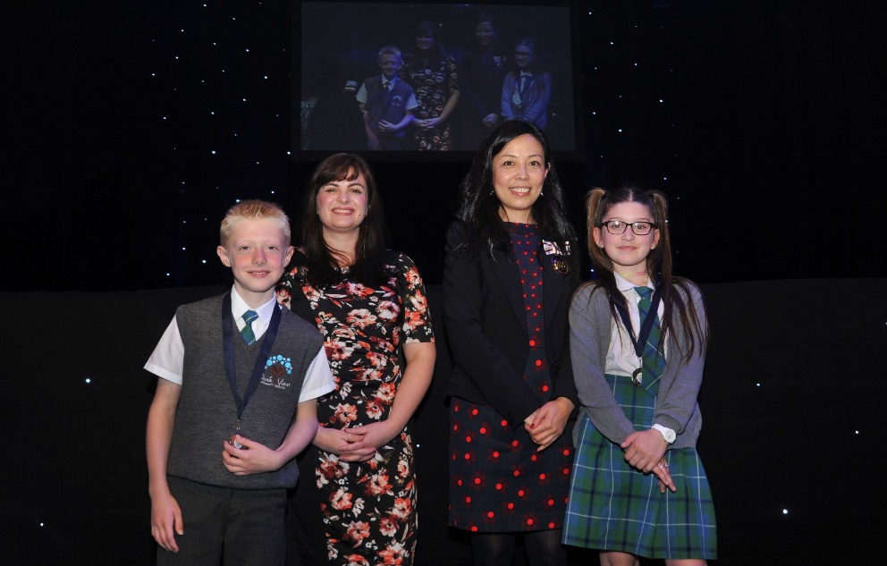
Aaron in P5 and Sophie in P4 won awards at the SLC pupil award ceremony. Aaron won his award for achievements in football and Sophie won hers for being a great ambassador for the school.

It has been another busy but incredibly successful year at Park View Primary!

Comment on strategies that have been successful in engaging with children and young people, staff, parents and the wider community and the impact of these.
- We increased the number of pupil committees so that children feel they have more say in the running of the school.
- We sent out a wider range of ‘newsletters’ on different areas to try to keep parents more updated on school events and achievements.
- Staff continue to have input into the school improvement plan and are regularly encouraged to put forward their own ideas.
- We have continued to work well with schools in the learning community and Stonelaw High by taking part in a variety of events.
- Parents were again able to come into the school on several occasions to take part in learning activities with their children or find out more about different initiatives.
- With the support of the Active Schools coordinator, we engaged with a variety of local sporting clubs

- Self-Evaluation of Quality Indicators

Quality Indicator | How are we doing? | How do we know? | School Self-Evaluation
1.1  Self-Evaluation for Self-Improvement | - Staff continue to participate in a range of quality assurance activities including self and peer evaluation.  - We continue to seek feedback from pupils and parents on things we are doing well and what we can improve on.  - We hold regular planning and tracking meetings with a clear focus on pupil progress and what can be done to increase attainment.  - Our school improvement plan sets clear and realistic targets for improvement and stakeholders have an input into creating it.  - All staff have yearly PRD meetings and self-evaluate against appropriate GTCs standards.  - All teaching staff are part of a curriculum group. Each group is responsible for evaluating and area of the improvement plan and taking new ideas forward.  - During next session, we plan to reintroduce our pupil evaluation team to carry out learning and teaching visits. | - Classroom visits  - Completion of questionnaires and surveys  - Planning/Tracking meetings  - Annual PRD meetings  - All Teaching staff involved in Curriculum Development Groups | Very Good
1.3  Leadership of Change | - All members of teaching staff and almost all support staff lead at least one initiative in the school.  - Some members of staff lead or have led initiatives, or play a leading role in them, across the learning community.  - We have 10 pupil groups/committees, which are led by children with support from different members of staff.  - Staff in the school are very forward thinking and keen to lead new initiatives e.g. learning through play.  - Staff have opportunities at PRD meetings to discuss leadership opportunities. | - PRD meetings  - The number of staff who lead initiatives  - Minutes from meetings and updates from committees given at monthly assemblies. | Very Good
2.3  Learning, teaching and assessment | - We have a structured and consistent approach to learning and teaching.  - Classroom visits are carried out by the management team, peers and pupils. Feedback is given to individuals but any general areas of strength or concerns are shared as a staff team.  - Considering the school is only in its sixth year, very good progress has been made to establish a curriculum.  - We make changes to planners, e.g. adding interim benchmark statements, as required with the aim of making the learning and teaching more consistent.  - Teaching staff have termly planning/tracking meetings with a focus on assessment and trying to raise attainment.  - Staff are now making much better use of the tracking and monitoring database to help identify strengths and areas that need improvement.  - Staff are now more confident in using standardised assessments to identify strengths and plan next steps in learning. | - Feedback from classroom visits  - Curriculum Development groups  - Staff confidence in using tracking and monitoring database  - Planning and tracking meetings  - Increased attainment | Good
3.1  Ensuring wellbeing, equity and inclusion | - We are an extremely nurturing and inclusive school with a very positive ethos.  - A particular strength is the positive relationships that exist between all staff. Teamwork amongst staff is very strong.  - There are a wide range of interventions in place to support the wellbeing of pupils.  - Almost all staff have undertaken additional professional learning in at least one approach to ensure pupil wellbeing.  - We evaluate and track pupil wellbeing consistently and try to address any issues promptly.  - All children are aware of the ‘Rights of The Child’ and all classes have charters created by pupils. These are recreated each year.  - Pupils across this school are given many opportunities to attend extra-curricular clubs. We increased the amount of these held during the school day to try to be even more inclusive. 85% of the pupils have attended at least one extra-curricular club during this session. | - Classroom visits  - Positive professional dialogue amongst all staff  - Feedback from external visitors  - Feedback from parents/carers and other stake holders  - Analysis of data provided by Active Schools | Very Good
3.2 Raising attainment and achievement | - Pupil achievement is celebrated at monthly achievement assemblies and via the school Twitter account.  - All classes have a ‘Wall of Fame’ where pupil achievements are displayed.  - We have raised attainment with regards to Cfe levels, in Numeracy (81%), Writing (76%) and Listening and Talking (84%). Reading has remained at the same level (66%). Despite the reading attainment level, with regards to Cfe levels remaining the same, significant progress has been made in raising attainment in Reading through the ‘Catch up Literacy’ intervention. 24 pupils have been working on this intervention. There has been an increase in reading age and reading comprehension of 16.5 months and the standardised score has gone up by approximately 8.  - We have closed the gap in all 4 areas | - Number of followers and comments on Twitter  - Classroom visits  - Amount of achievements displayed on class ‘wall of fames’  - Data from tracking and monitoring database | Good

- Overall Evaluation

Overall evaluation of establishment’s capacity for continuous improvement
- Park View’s role has continued to rise since the school opened in August 2013. Next year’s P7 cohort were the first P1s. This means that the role should stabilize going forward.
- The staff are extremely hard working and innovative. There is also more consistency to the staff team.
- We continue to offer a wide range of HWB interventions and staff are happy to share their knowledge and skills to allow other staff to develop theirs.
- Our attainment has risen during this session and staff are more aware of different interventions that can be put in place to support our learners.
- Staff are now more confident in using the tracking and monitoring database to access assessment data and are using this to plan next steps in learning.
- Again, from using the database, staff are more familiar with groups of pupils to target to help raise attainment and close the attainment gap.
- Due to our strong self-evaluation, we are able to see areas in which we are doing well and identify our development needs.
- All staff are aware of the areas for improvement in the SIP for next session and we continue to engage with all stakeholders in terms of highlighting both strengths, and areas for development.

Signed: Campbell McKissock (Acting HT)

Date: June 2019

